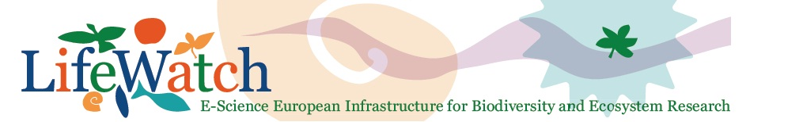

Lifewatch data analysis workshop
Biodiversity data preparation and analysis using the LifeWatch Virtual Labs and web services
LifeWatch is building an European infrastructure to support biodiversity research and ecosystem studies. Within the envisaged e-infrastructure of LifeWatch, data exchange and data analysis are largely based on the use of web services. Building on the LifeWatch Taxonomic Backbone, a growing number of these web services is being set up. Workflows or Virtual Labs are being developed making use of these services to automate recurring data preparation and analysis tasks. The goal of this course is to get researchers introduced with the advantages of using web services, get acquainted with existing Virtual Labs and workflows and build their own workflows on top of the available services.

Thursday 26th – Friday 27th November 2015; InnovOcean site, Wandelaarkaai 7, Oostende
Training room IODC, first floor (entrance IOC/PAK, warehouse 61)

Thursday November 26th 2015

10:00-12:30 Pre-workshop: Introduction to R

12:30-13:00 Lunch

13:00-13:15 Welcome and overview of the LifeWatch Data Analysis Workshop

13:15-14:00 Introduction to web services and LifeWatch virtual labs

14:00-15:00 Data standardization and quality control using LifeWatch Virtual Lab services

15:00-15:15 Coffee break

15:15-16:30 Data retrieval and access using the LifeWatch web services

Friday November 27th 2015

9:00-12:30 Data exploration, visualization and analysis

10:45-11:00 Coffee break

11:00-13:00 Data exploration, processing and analysis

13:00-14:00 End of the workshop and lunch

